Creating IAM Roles

Lab Steps

Task 1: Sign in to AWS Management Console
- Click on the Open Console button, and you will get redirected to AWS Console in a new browser tab.
- On the AWS sign-in page,
  - Leave the Account ID as default. Never edit/remove the 12 digit Account ID present in the AWS Console. otherwise, you cannot proceed with the lab.
  - Now copy your User Name and Password in the Lab Console to the IAM Username and Password in AWS Console and click on the Sign in button.
- Once Signed In to the AWS Management Console, Make the default AWS Region as US East (N. Virginia) us-east-1.
Note : If you face any issues, please go through FAQs and Troubleshooting for Labs.

Task 2: Creating Role for an EC2 Service
- Navigate to IAM by clicking on the Services menu at the top, then click on IAM in the Security, identity, & Compliance section.
- In the left menu, select Roles.
- Click on Create Role button.
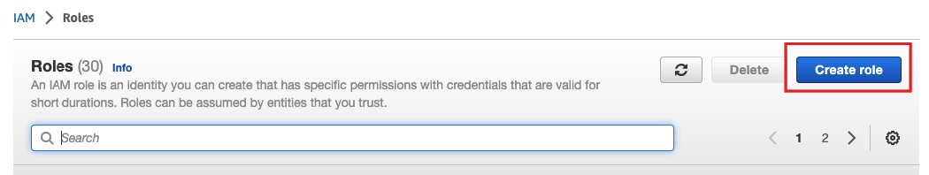
- EC2 should be selected as the type of trusted entity under Use Case. Then click on Next button.
- In Attach permissions policies, type EC2 in the Filter Policies and select AmazonEC2FullAccess
- Note: Do not add other policies than the mentioned above. You will get an error while creating the Role.
- Then click on Next button
- Review: Role name
- Role Name : Enter EC2Role
- Review the role and then choose Create role button
- After creating, you will get a verification for the created Role.

9. When searching for our role name, you will see the created role populate.
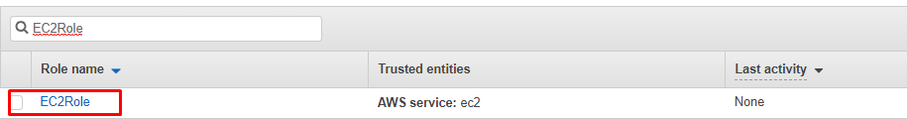
- When you set up an AWS service environment, you must define a role for the service to assume. You can attach this Role to the AWS services. This service role must include all the permissions required for the service to access the AWS resources that it needs.
- This allows EC2 to perform actions on our behalf.

Task 3: Creating Role for an AWS Service - DynamoDB
- In the left menu, select Roles.
- Click on Create Role button

3. For DynamoDB should be selected as the type of trusted entity under Use Case.
4. Select the Use case as Amazon DynamoDB Accelerator (DAX) - DynamoDB access.
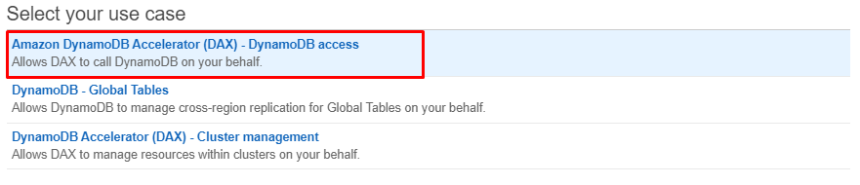
- Then click on Next button
- In Attach permissions policies, you can see AmazonDynamoDBFullAccess.
Note: Do not add other policies than the mentioned above. You will get an error while creating the Role.
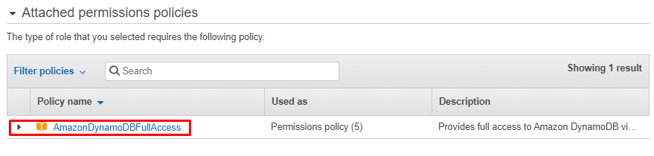
- Then click on Next button
- Review:
  - Role Name : Enter DynamoDBRole
  - Review the role and then choose Create role button
- After creating, you will get a verification for the created Role.

- When searching for our role name, you will see the created role populate.
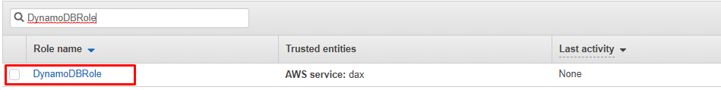
- When you set up an AWS service environment, you must define a role for the service to assume.You can attach this Role to the AWS services. This service role must include all the permissions required for the service to access the AWS resources that it needs.
- This allows DynamoDB to perform actions on our behalf.

Do you know ?
An IAM role is an IAM identity that you can create in your account that has specific permissions. An IAM role is similar to an IAM user, in that it is an AWS identity with permission policies that determine what the identity can and cannot do in AWS. However, instead of being uniquely associated with one person, a role is intended to be assumable by anyone who needs it.

